To the Max! (...imum Gradient...).

Imagine you are an extreme sports holiday company. You've been given raster data of the heights for a hilly area, and you want to find the most extreme gradients on which to set up snowboard runs. The raster data will be text numbers of metres above sea level.

Write a program which does the following.

1. Pulls in the hillslope heights from a file.
2. Calculates the maximum slope in all the raster cells.

**To do this use the "D8" algorithm.**

This calculates the slope between a cell and its eight neighbours, using their height and distance from the cell (this will be one for four of the neighbours, and the square root of two for the other four). The maximum slope is then the greatest of these values. If you get two maximum slopes for a given cell you need to be careful your program doesn't break! You'll also need to think about what to do at the map edges.

1. Builds a data set that has the slope gradients in it rather than the heights.
2. Displays the heights and the gradients as images.
3. Saves the gradients to a file in a similar format to the heights.

Files for this project.

* A file of values representing a 300 x 300 raster grid of heights: [snow.slope](https://www.geog.leeds.ac.uk/courses/computing/study/core-python-odl2/assessment2/snow.slope) (GIF version for comparison - this should not be used in the project). Each line in the file represents a line in the raster image, starting at the top left.

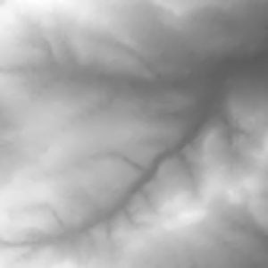

D8 Slope Analysis

https://docs.qgis.org/2.8/en/docs/user_manual/processing_algs/taudem/basic_grid_analysis_tools.html

[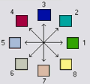](https://docs.qgis.org/2.8/en/_images/d8index.gif)Creates 2 grids. The first contains the flow direction from each grid cell to one of its adjacent or diagonal neighbours, calculated using the direction of steepest descent. The second contain the slope, as evaluated in the direction of steepest descent, and is reported as drop/distance, i.e. tan of the angle. Flow direction is reported as NODATA for any grid cell adjacent to the edge of the DEM domain, or adjacent to a NODATA value in the DEM. In flat areas, flow directions are assigned away from higher ground and towards lower ground using the method of Garbrecht and Martz (1997). The D8 flow direction algorithm may be applied to a DEM that has not had its pits filled, but it will then result in NODATA values for flow direction and slope at the lowest point of each pit.

D8 Flow Direction Coding:

1 — East

2 — Northeast

3 — North

4 — Northwest

5 — West

6 — Southwest

7 — South

8 — Southeast

The flow direction routing across flat areas is performed according to the method described by:

Garbrecht, J. and L. W. Martz, (1997), “The Assignment of Drainage Direction Over Flat Surfaces in Raster Digital Elevation Models”, Journal of Hydrology, 193: 204-213.

How Flow Direction works

One of the keys to deriving hydrologic characteristics of a surface is the ability to determine the direction of flow from every cell in the raster. This is done with the [Flow Direction](https://pro.arcgis.com/en/pro-app/tool-reference/spatial-analyst/flow-direction.htm) tool.

This tool takes a surface as input and outputs a raster showing the direction of flow out of each cell. If the **Output drop raster** option is chosen, an output raster is created showing a ratio of the maximum change in elevation from each cell along the direction of flow to the path length between centers of cells and is expressed in percentages. If the **Force all edge cells to flow outward** option is chosen, all cells at the edge of the surface raster will flow outward from the surface raster.

There are eight valid output directions relating to the eight adjacent cells into which flow could travel. This approach is commonly referred to as an eight-direction (D8) flow model and follows an approach presented in Jenson and Domingue (1988).

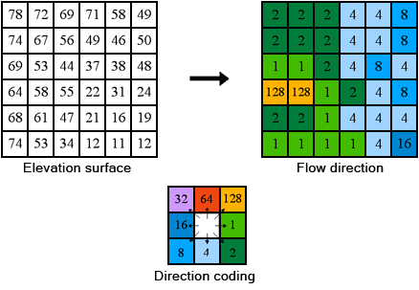The coding of the direction of flow

Calculating the direction of flow

The direction of flow is determined by the direction of steepest descent, or maximum drop, from each cell. This is calculated as follows:

**maximum_drop = change_in_z-value / distance * 100**

The distance is calculated between cell centres. Therefore, if the cell size is 1, the distance between two orthogonal cells is 1, and the distance between two diagonal cells is 1.414 (the square root of 2). If the maximum descent to several cells is the same, the neighbourhood is enlarged until the steepest descent is found.

When a direction of steepest descent is found, the output cell is coded with the value representing that direction.

If all neighbours are higher than the processing cell, it will be considered noise, be filled to the lowest value of its neighbours, and have a flow direction toward this cell. However, if a one-cell sink is next to the physical edge of the raster or has at least one NoData cell as a neighbour, it is not filled due to insufficient neighbour information. To be considered a true one-cell sink, all neighbour information must be present.

If two cells flow to each other, they are sinks and have an undefined flow direction. This method of deriving flow direction from a digital elevation model (DEM) is presented in Jenson and Domingue (1988).

Cells that are sinks can be identified using the [Sink](https://pro.arcgis.com/en/pro-app/tool-reference/spatial-analyst/sink.htm) tool. To obtain an accurate representation of flow direction across a surface, the sinks should be filled before using a flow direction raster.

**References**

Greenlee, D. D. 1987. "Raster and Vector Processing for Scanned Linework." Photogrammetric Engineering and Remote Sensing 53 (10): 1383–1387.

Jenson, S. K., and J. O. Domingue. 1988. "Extracting Topographic Structure from Digital Elevation Data for Geographic Information System Analysis." Photogrammetric Engineering and Remote Sensing 54 (11): 1593–1600.